Constructing Square

Definition
# Source: AI Source: Provided by: [Data Path: Persons Table -> ID Column: 1, Name_En Column: Motasem Essam] -> From: [ChatGPT] on [7/25/2026]
Constructing a Square is the geometric construction of a quadrilateral with four equal sides and four right angles using classical geometric tools, primarily a straightedge and compass.
A square $ABCD$satisfies:
$$\boxed{AB=BC=CD=DA}$$
and
$$\boxed{∠A=∠B=∠C=∠D={90}^{∘}}$$
A square is therefore both a regular quadrilateral and a rectangle and rhombus.

Fundamental Concept
# Source: AI Source: Provided by: [Data Path: Persons Table -> ID Column: 1, Name_En Column: Motasem Essam] -> From: [ChatGPT] on [7/25/2026]
A square can be constructed from different types of given information, such as:
- one given side
- two endpoints of a given side
- a given diagonal
- a given center
- a given side and a direction
The most fundamental construction is constructing a square on a given line segment.
If $\overset{‾}{AB}$is the given side, the goal is to construct points $C$and $D$such that:
$$AB=BC=CD=DA$$
and:
$$AB⊥AD, AB⊥BC$$

Main Construction: Square on a Given Side
# Source: AI Source: Provided by: [Data Path: Persons Table -> ID Column: 1, Name_En Column: Motasem Essam] -> From: [ChatGPT] on [7/25/2026]
Suppose $\overset{‾}{AB}$is the given side.
Steps
- Draw or identify the given segment $\overset{‾}{AB}$.
- Construct a perpendicular line to $AB$through $A$.
- Construct a perpendicular line to $AB$through $B$, on the same side of $AB$.
- Set the compass to the length $AB$.
- On the perpendicular through $A$, mark point $D$such that:
$$AD=AB$$
- On the perpendicular through $B$, mark point $C$such that:
$$BC=AB$$
- Connect $C$and $D$.
- The resulting quadrilateral $ABCD$is a square.
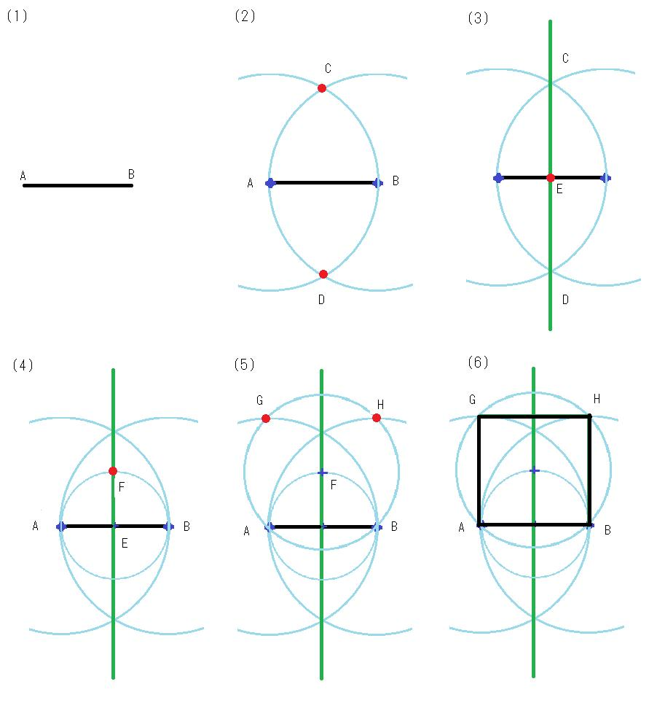
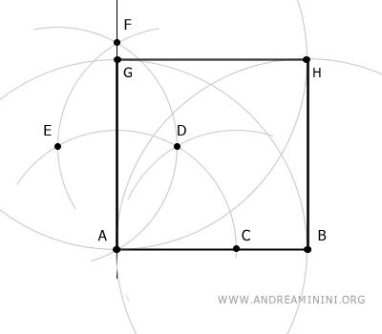
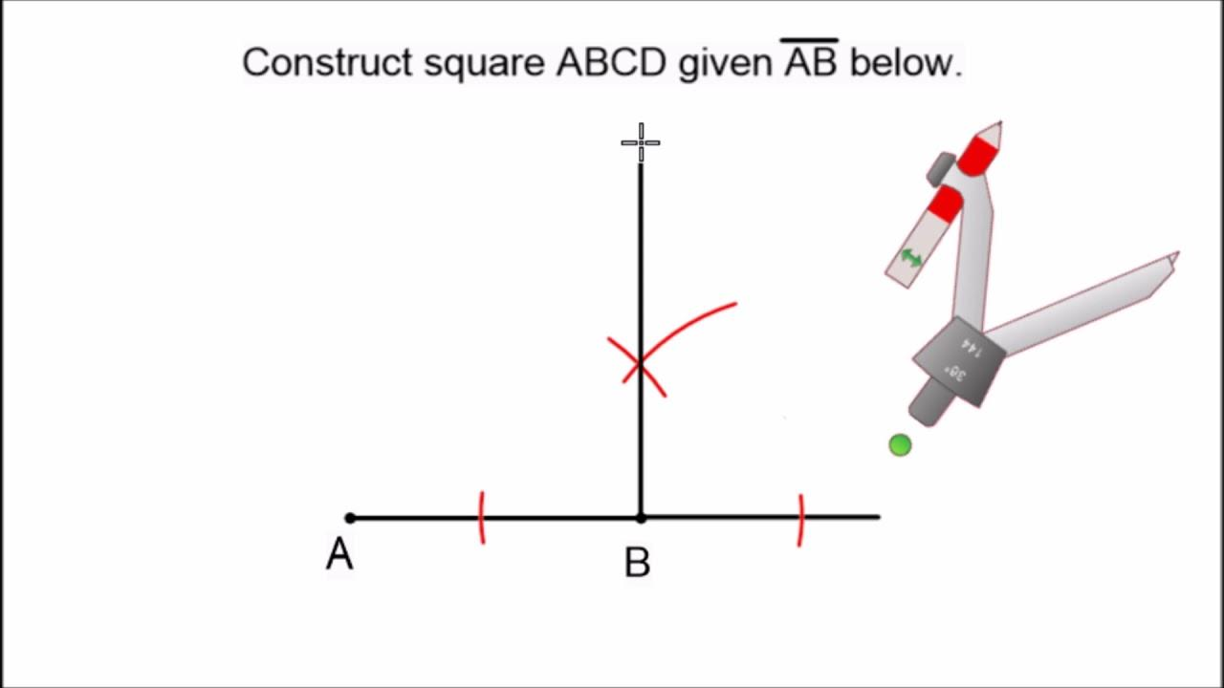
Result
$$\boxed{AB=BC=CD=DA}$$
and:
$$\boxed{∠A=∠B=∠C=∠D={90}^{∘}}$$
Therefore:
$$\boxed{ABCD\text{ is a square}}$$

Why the Construction Works
# Source: AI Source: Provided by: [Data Path: Persons Table -> ID Column: 1, Name_En Column: Motasem Essam] -> From: [ChatGPT] on [7/25/2026]
The perpendiculars at $A$and $B$create right angles:
$$AD⊥AB$$
and
$$BC⊥AB$$
Therefore:
$$∠DAB=∠ABC={90}^{∘}$$
Since:
$$AD=AB$$
and
$$BC=AB$$
we have:
$$AD=BC$$
The two perpendicular lines are parallel to each other, so $AD∥BC$.
Because $AB$is perpendicular to both, the resulting quadrilateral has four right angles and equal sides.
Thus:
$$\boxed{ABCD\text{ is a square}}$$

Construction Using a Given Side Length
# Source: AI Source: Provided by: [Data Path: Persons Table -> ID Column: 1, Name_En Column: Motasem Essam] -> From: [ChatGPT] on [7/25/2026]
If only a length $s$is specified, first construct a segment:
$$AB=s$$
Then construct the square on $AB$.
The side lengths are:
$$\boxed{AB=BC=CD=DA=s}$$
The perimeter is:
$$\boxed{P=4s}$$
and the area is:
$$\boxed{A=s^{2}}$$
The diagonal is:
$$\boxed{d=s\sqrt{2}}$$

Constructing a Square from a Given Diagonal
# Source: AI Source: Provided by: [Data Path: Persons Table -> ID Column: 1, Name_En Column: Motasem Essam] -> From: [ChatGPT] on [7/25/2026]
A square can also be constructed when its diagonal is given.
Suppose $\overset{‾}{AC}$is the given diagonal.
Steps
- Draw the given diagonal $AC$.
- Construct the perpendicular bisector of $AC$.
- Let the midpoint of $AC$be $O$.
- Set the compass radius to:
$$OA=OC$$
- On the perpendicular bisector, mark points $B$and $D$such that:
$$OB=OD=OA$$
- Connect:
$$A-B-C-D-A$$
- The resulting quadrilateral is a square.
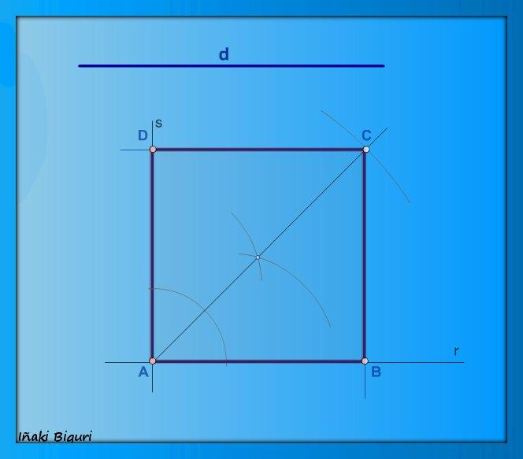
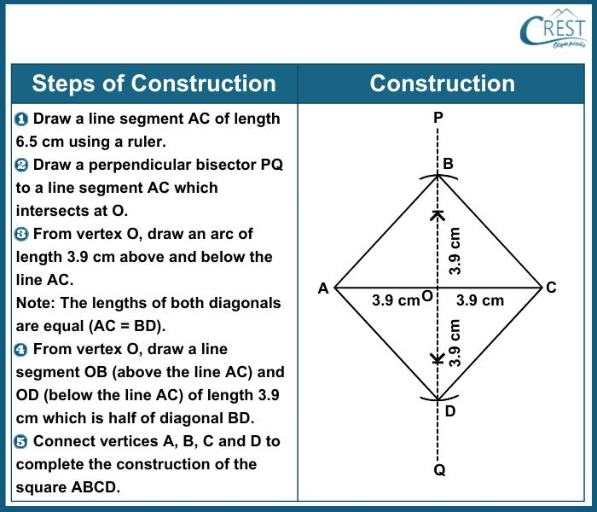
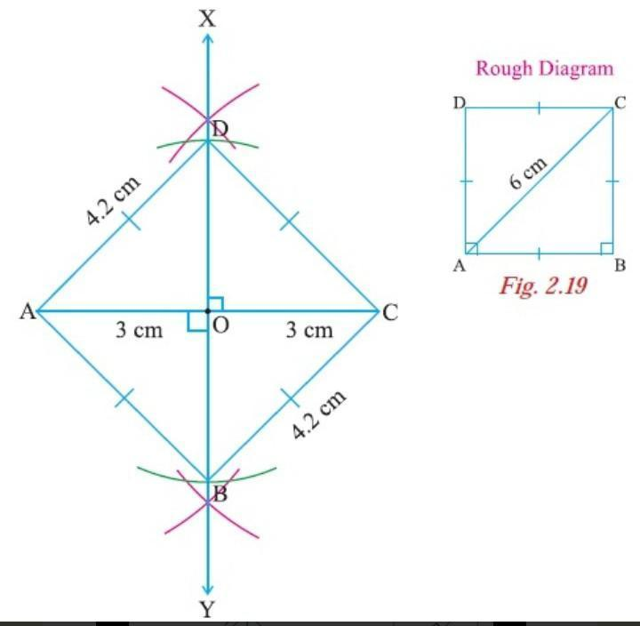
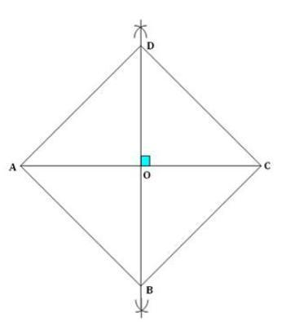
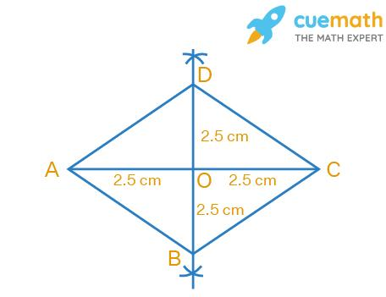
For a square with diagonal $d$, each side is:
$$\boxed{s=\frac{d}{\sqrt{2}}=\frac{d\sqrt{2}}{2}}$$

Constructing a Square from Its Center
# Source: AI Source: Provided by: [Data Path: Persons Table -> ID Column: 1, Name_En Column: Motasem Essam] -> From: [ChatGPT] on [7/25/2026]
If the center $O$and a vertex $A$are given:
- Draw $OA$.
- Construct a perpendicular line through $O$.
- Mark $C$on the opposite side such that:
$$OA=OC$$
- Construct the perpendicular bisector of $OA$, or use the appropriate ${45}^{∘}$directions.
- Locate vertices $B$and $D$so that:
$$OA=OB=OC=OD$$
with consecutive vertices separated by ${90}^{∘}$.
- Connect the four vertices.
The center satisfies:
$$\boxed{OA=OB=OC=OD}$$
and the diagonals bisect each other at right angles:
$$\boxed{AC⊥BD}$$

Important Properties of a Constructed Square
# Source: AI Source: Provided by: [Data Path: Persons Table -> ID Column: 1, Name_En Column: Motasem Essam] -> From: [ChatGPT] on [7/25/2026]
For square $ABCD$:
Sides
$$\boxed{AB=BC=CD=DA}$$
Angles
$$\boxed{∠A=∠B=∠C=∠D={90}^{∘}}$$
Opposite sides
$$\boxed{AB∥CD} \\ \boxed{AD∥BC}$$
Diagonals
$$\boxed{AC=BD}$$
and:
$$\boxed{AC⊥BD}$$
The diagonals also bisect each other:
$$\boxed{AO=OC} \\ \boxed{BO=OD}$$
Diagonal relationship
$$\boxed{d=s\sqrt{2}}$$

Types of Square Construction
# Source: AI Source: Provided by: [Data Path: Persons Table -> ID Column: 1, Name_En Column: Motasem Essam] -> From: [ChatGPT] on [7/25/2026]
The following are construction situations, rather than different mathematical types of squares:
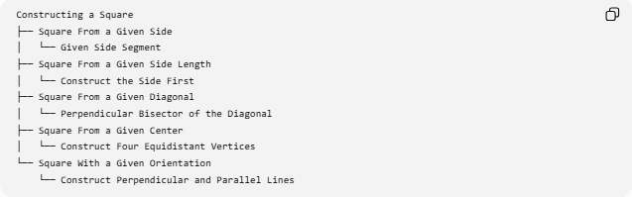
Constructing a Square
├── Square From a Given Side
│ └── Given Side Segment
├── Square From a Given Side Length
│ └── Construct the Side First
├── Square From a Given Diagonal
│ └── Perpendicular Bisector of the Diagonal
├── Square From a Given Center
│ └── Construct Four Equidistant Vertices
└── Square With a Given Orientation
└── Construct Perpendicular and Parallel Lines

Square Construction and Other Geometric Constructions
# Source: AI Source: Provided by: [Data Path: Persons Table -> ID Column: 1, Name_En Column: Motasem Essam] -> From: [ChatGPT] on [7/25/2026]
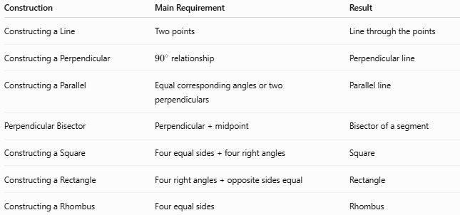
Construction | Main Requirement | Result
Constructing a Line | Two points | Line through the points
Constructing a Perpendicular | ${90}^{∘}$relationship | Perpendicular line
Constructing a Parallel | Equal corresponding angles or two perpendiculars | Parallel line
Perpendicular Bisector | Perpendicular + midpoint | Bisector of a segment
Constructing a Square | Four equal sides + four right angles | Square
Constructing a Rectangle | Four right angles + opposite sides equal | Rectangle
Constructing a Rhombus | Four equal sides | Rhombus
The construction of a square combines several basic constructions, especially:
$$\boxed{\text{Line Segment}+\text{Perpendicular}+\text{Equal Lengths}+\text{Parallel Lines}}$$

Construction Classification
# Source: AI Source: Provided by: [Data Path: Persons Table -> ID Column: 1, Name_En Column: Motasem Essam] -> From: [ChatGPT] on [7/25/2026]
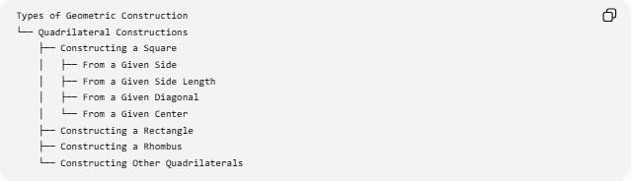
Types of Geometric Construction
└── Quadrilateral Constructions
├── Constructing a Square
│ ├── From a Given Side
│ ├── From a Given Side Length
│ ├── From a Given Diagonal
│ └── From a Given Center
├── Constructing a Rectangle
├── Constructing a Rhombus
└── Constructing Other Quadrilaterals
A more detailed relationship is:
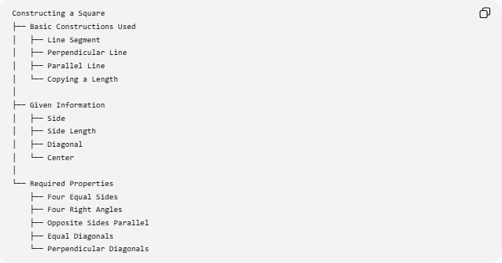
Constructing a Square
├── Basic Constructions Used
│ ├── Line Segment
│ ├── Perpendicular Line
│ ├── Parallel Line
│ └── Copying a Length
│
├── Given Information
│ ├── Side
│ ├── Side Length
│ ├── Diagonal
│ └── Center
│
└── Required Properties
├── Four Equal Sides
├── Four Right Angles
├── Opposite Sides Parallel
├── Equal Diagonals
└── Perpendicular Diagonals

Example
# Source: AI Source: Provided by: [Data Path: Persons Table -> ID Column: 1, Name_En Column: Motasem Essam] -> From: [ChatGPT] on [7/25/2026]
Given:
$$AB=5\text{ cm}$$
Construct a square $ABCD$.
Since all sides of a square are equal:
$$BC=CD=DA=5\text{ cm}$$
The perimeter is:
$$P=4\left(5\right)=20\text{ cm}$$
The area is:
$$A=5^{2}=25{\text{ cm}}^{2}$$
The diagonal is:
$$d=5\sqrt{2}\text{ cm}$$
Therefore, the constructed square has:
$$\boxed{\text{Side}=5\text{ cm}} \\ \boxed{\text{Perimeter}=20\text{ cm}} \\ \boxed{\text{Area}=25{\text{ cm}}^{2}} \\ \boxed{\text{Diagonal}=5\sqrt{2}\text{ cm}}$$

Tools Used
# Source: AI Source: Provided by: [Data Path: Persons Table -> ID Column: 1, Name_En Column: Motasem Essam] -> From: [ChatGPT] on [7/25/2026]
Straightedge
Used to:
- draw straight lines
- connect constructed points
- extend lines
Compass
Used to:
- transfer the side length
- draw arcs
- locate points at equal distances
Thus, classical square construction uses:
$$\boxed{\text{Straightedge + Compass}}$$

Key Points
# Source: AI Source: Provided by: [Data Path: Persons Table -> ID Column: 1, Name_En Column: Motasem Essam] -> From: [ChatGPT] on [7/25/2026]
- A square has four equal sides.
- A square has four ${90}^{∘}$angles.
- To construct a square on a given side, construct perpendiculars at the two endpoints and transfer the side length.
- Opposite sides of the constructed square are parallel.
- The diagonals are equal.
- The diagonals bisect each other.
- The diagonals are perpendicular.
- A square can also be constructed from a given diagonal.
- The diagonal and side are related by:
$$d=s\sqrt{2}$$
- The area is:
$$A=s^{2}$$
- The perimeter is:
$$P=4s$$

Conclusion
# Source: AI Source: Provided by: [Data Path: Persons Table -> ID Column: 1, Name_En Column: Motasem Essam] -> From: [ChatGPT] on [7/25/2026]
Constructing a Square is a geometric construction that creates a quadrilateral having four equal sides and four right angles. The fundamental method starts with a given side, constructs perpendicular lines at its endpoints, and transfers the same side length to locate the remaining vertices. More advanced constructions can begin with a given diagonal or center. The construction combines several fundamental geometric techniques, particularly line-segment construction, perpendicular construction, parallel-line construction, and transferring equal lengths.

